Heavy Weight #6

**Series #1 w/o strip; Series #2 w/strip**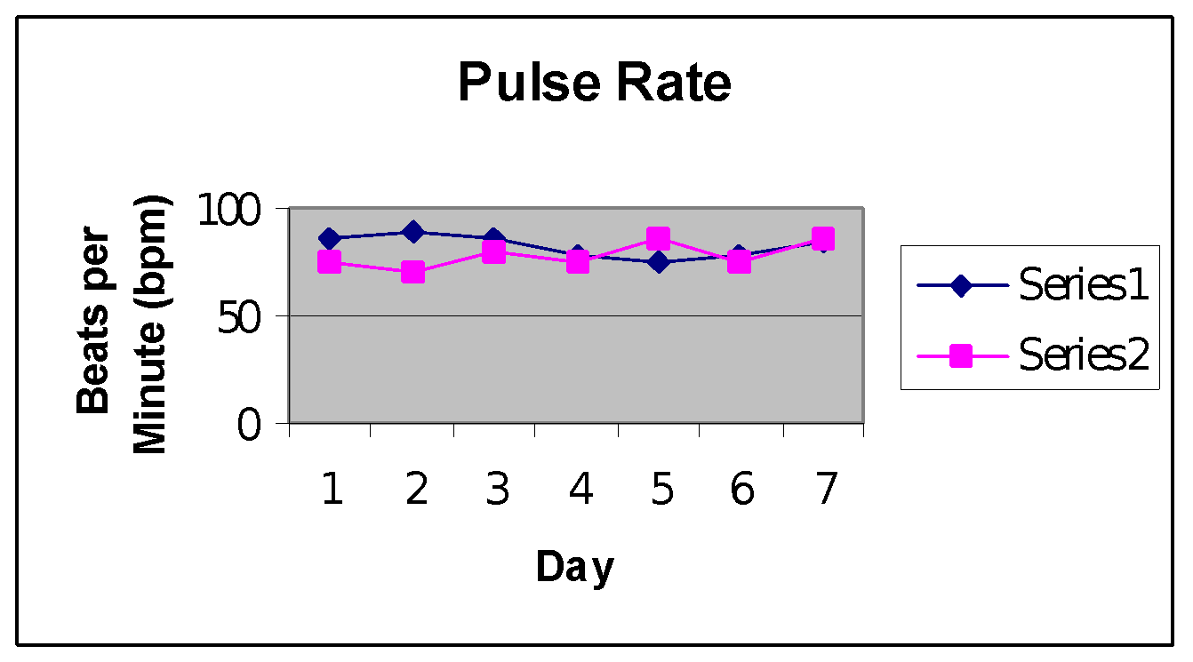

Series #1 mean: 82.356 bpm; Series #2 mean: 78.4717 bpm

The Series #2 mean has a .0199 probability of occurring by chance when compared to the Series #1 mean. This gives strong evidence that the nasal strip decreased the pulse rate of the subject.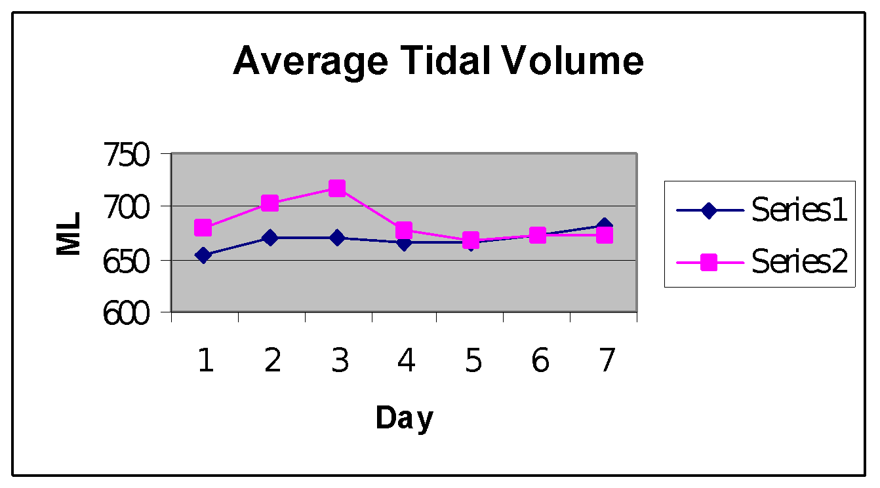

Series #1 mean : 668.788 ml; Series #2 mean: 683.9398 ml

The Series #2 mean has a .084 probability of occurring by chance when compared to the Series #1 mean. This gives strong evidence that the nasal strip increased the subjects tidal volume.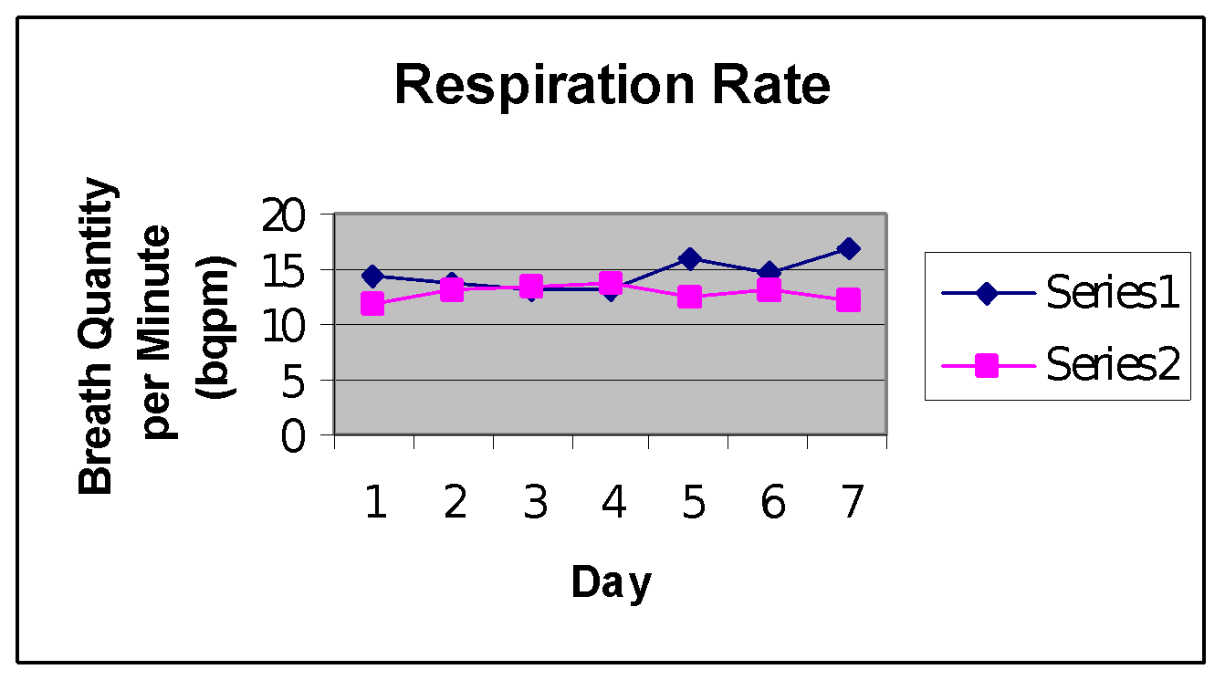

Series #1 mean: 14.005 bqpm; Series #2 mean: 12.8218 bqpm

The Series #2 mean has less than a .001 probability of occurring by chance when compared with the Series #1 mean. This gives strong evidence that the nasal strip decreased the subject’s respiratory rate.

Series #1 mean: 290,926.79 ml; Series #2 mean: 263,079.834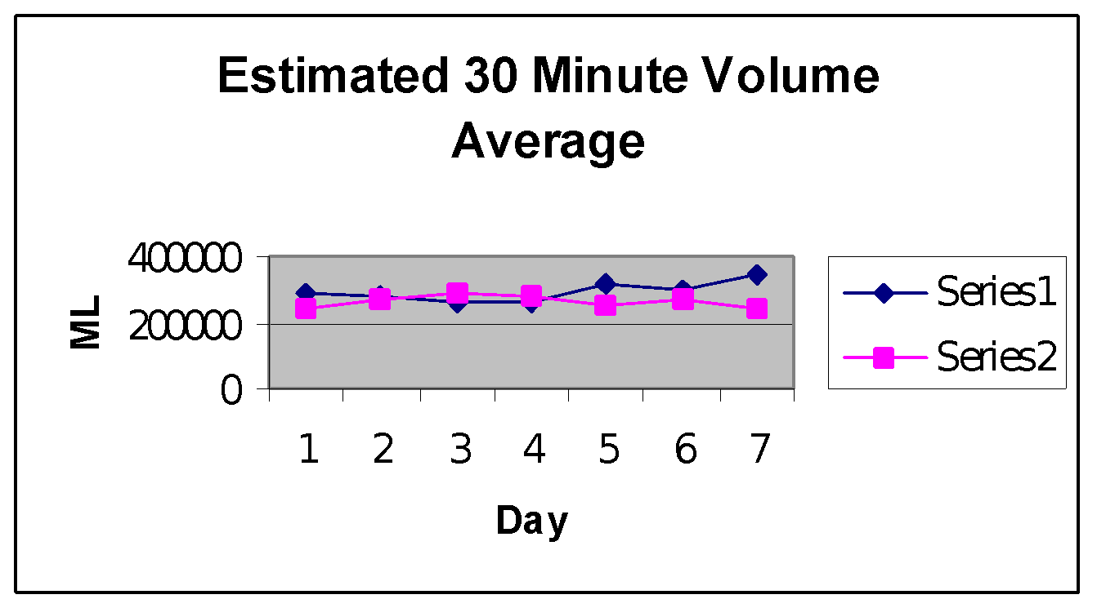

The Series #2 mean has a .0967 probability of occurring by chance when compared to the Series #1 mean. This gives strong evidence that the nasal strip decreased the 30 minute volume respired by the subject.